Photo Captions
Photos | Suggested Captions
Photo 1 – 3  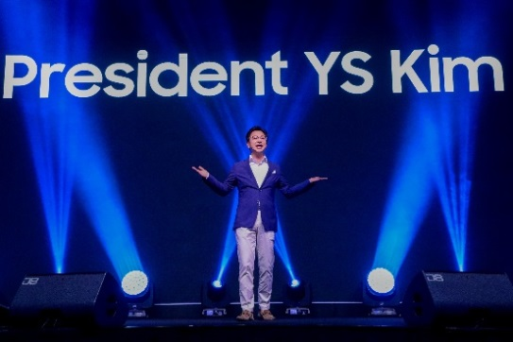  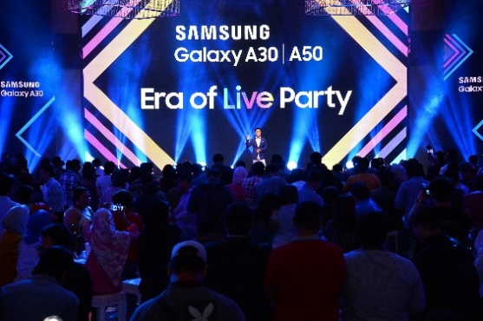  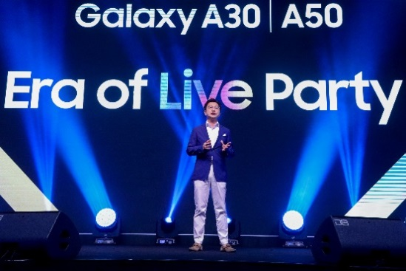 | Yoonsoo Kim, President of Samsung Malaysia Electronics takes the stage for his welcome remark at the Era of Live official launch.
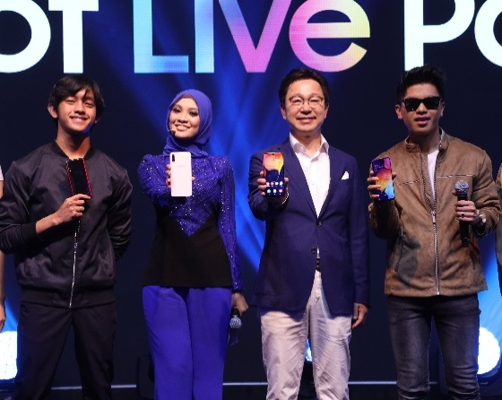  Photo 4 | (second from right) Yoonsoo Kim, President of Samsung Malaysia Electronics, together with the A-Squad (L-R) Ismail Izzani, Nabila Razali, and Haqiem Rusli showing the sleek design and stunning display of the new Galaxy A50 and A30.
  Photo 5 | Hi, I’m using the Samsung Galaxy A50, please don’t be jealous. (L-R) The A-Squad, Ismail Izzani, Nabila Razali, and Haqiem Rusli shared what they love about their Samsung Galaxy A50 at the Era of Live party.
Photo 6  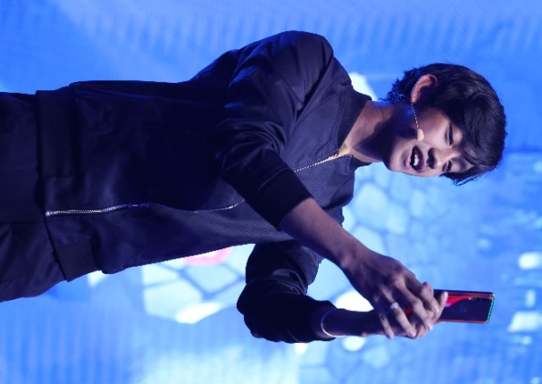 | Ismail Izzani loves the ultra-wide angle camera on his Samsung Galaxy A50, taking a picture of the crowd at the launch.
Photo 7  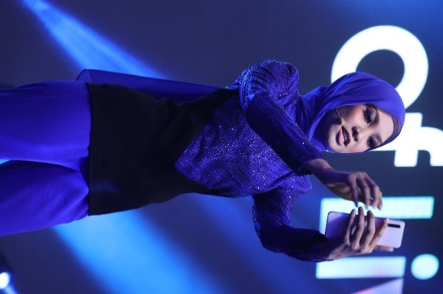 | Nabila Razali loves the immersive mobile experience that come with the super AMOLED screen on her Samsung Galaxy A50, which brings content to life.
Photo 8 - 9  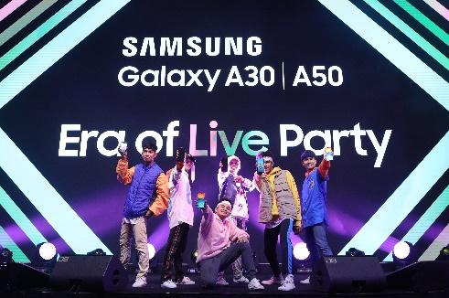  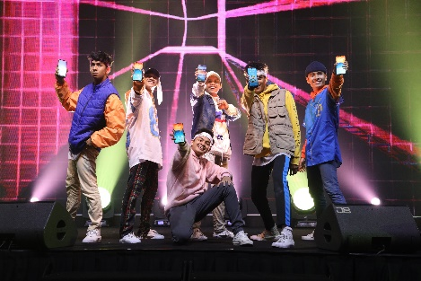 | Hey ho! The Galaxy A50 and A30 was unveiled in style, substance and spontaneity with a special dance performance at the Era of Live party.
Photo 10   | The influencers are taking group photo shot in line with pop of rainbow just like #GalaxyA50
Photo 11   | The Galaxy A50 and A30 launch was made even more amazing with the one and only Calum Scott performing.
Photo 12   | (L-R) Dennis Yin, multi-talented personality; Calum Scott, singer-songwriter; and Maria Rahajeng, E! News Host taking advantage of the Samsung Galaxy A50’s Selfie Focus function.

