Sink into sound, sync into your world: The Samsung Galaxy Buds2 Pro is officially up for pre-order now

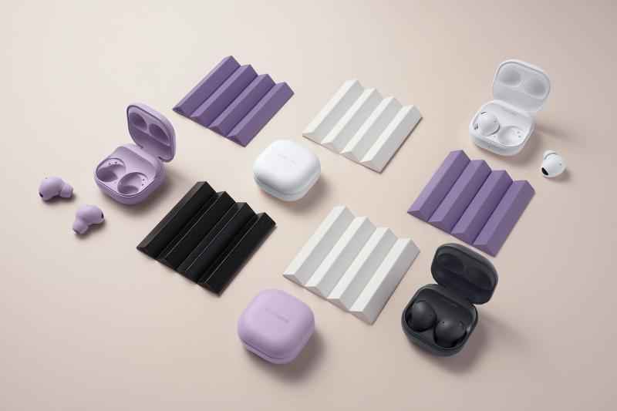

Samsung just dropped its most powerful and premium wireless earbuds to date during the Galaxy Unpacked event held August 10. Following the footsteps of the Galaxy Buds Pro released in 2021, the Galaxy Buds2 Pro is designed to provide the most immersive wireless audio experience, enabling users to listen to sounds at the quality they were intended to be heard.

In a hectic world that inherently adores “the grind,” the easiest way to escape is to put on a pair of earbuds and sink into sound. Samsung knows there’s a special kind of comfort that can be found when listening to music or watching a feel-good series in the middle of a busy day. With the Galaxy Buds2 Pro, the immersive listening era has begun.
The Galaxy Buds2 Pro supports wireless 24bit Hi-Fi audio for crystal-clear sound resolution and higher dynamic range. With the new Samsung seamless codec(SSC HiFi), quality music is enabled to transfer without a pause, and the new coaxial 2-way speaker makes those sounds richer than ever.

The device also boasts superior Active Noise Cancellation technology which comes with a fully-adjustable level control, allowing better focus and additional audio clarity. With 3 High Signal to Noise Ratio (SNR) microphones—a first in the Galaxy Buds Series—the Galaxy Buds2 Pro excellently filters out noise so users can fully focus on things that are most important to them.

It also features Intelligent 360 Audio that follows the user’s head movements to deliver theater-like sound with every move. With this, users can completely sink into sound through the Galaxy Buds2 Pro’s improved head tracking response with motion prediction based on machine learning.

Transferring from one Galaxy device to another is easy, thanks to the Galaxy Buds2 Pro’s Auto-Switch feature. Users can enjoy seamless integration in the Galaxy ecosystem as the Buds2 Pro automatically switches from their smart TV to their phone.

When it comes to battery life, the Galaxy Buds2 Pro is a reliable daily companion with up to 8 hours of playback time and a total of 29 hours of play time with the charging case. It also gives 1 hour of playtime with only 5 minutes of charging time and is Qi-enabled for wireless charging. Other features include an IPX7 water resistance rating and an automatic Voice Detect technology, among others.

Aside from features that complement modern lifestyles, the Galaxy Buds2 Pro also boasts a stylish and compact design. A much more improved version of the original model, the Galaxy Buds2 Pro is ergonomically-designed for a more comfortable fit as it is 15% smaller than the Buds Pro. It comes in three trendy colors: Bora Purple, Graphite, and White.

The Galaxy Buds2 Pro is now available for pre-order until September 1, 2022 via samsung.com, Samsung Experience Stores, Authorized Samsung Stores, Lazada, Shopee, Abenson.com and MemoXpress Online. Customers who pre-order until September 1 can enjoy freebies and discounts worth up to PHP 6,495.

During the pre-order period, customers can enjoy either a PHP 1,500 Token for Samsung mobile products, or if they wish to purchase the new Galaxy Z Fold4 or Z Flip4, they are entitled to a 50% discount on the Galaxy Buds2 Pro and a 30% discount on the Galaxy Watch5 Series.

The Galaxy Buds2 Pro will be available in samsung.com, Samsung Experience Stores, select Authorized Samsung Stores, Lazada, Shopee, Abenson.com and MemoXpress Online for PHP 12,990 starting September 2, 2022.

Get ready to unlock greater possibilities with the Samsung Galaxy Buds2 Pro. For more
information, visit https://www.samsung.com/.

Safe Samsung Shopping

Health and safety protocols are strictly followed in Samsung Experience Stores to keep consumers and employees safe. Adhering to the guidelines set by the Inter-Agency Task Force for the Management of Emerging Infectious Diseases, Samsung has implemented the mandatory use of face masks, and performs frequent sanitation in all stores.

Samsung Experience Stores also has unique QR health declaration codes to promote a safe and contactless contact tracing process. Product demonstrations are done side-by-side instead of face-to-face while keeping the required safe distance of one (1) meter to make sure everyone is socially distanced.

To find the nearest Samsung Experience Store, visit samsung.com/ph/samsung-experience-store/locations.

###

About Samsung Electronics Co., Ltd.
Samsung inspires the world and shapes the future with transformative ideas and technologies. The company is redefining the worlds of TVs, smartphones, wearable devices, tablets, digital appliances, network systems, and memory, system LSI and LED solutions. For the latest news, please visit the Samsung Newsroom at http://news.samsung.com.

Samsung Galaxy device with One UI 4.0 or higher is required. 24-bit audio support may vary depending on the application.
Samsung Galaxy device with One UI version 4.0 or higher is required.

