Filipinos among the most sleepless in the world. Here’s how the newest Galaxy Watch5 Series can help

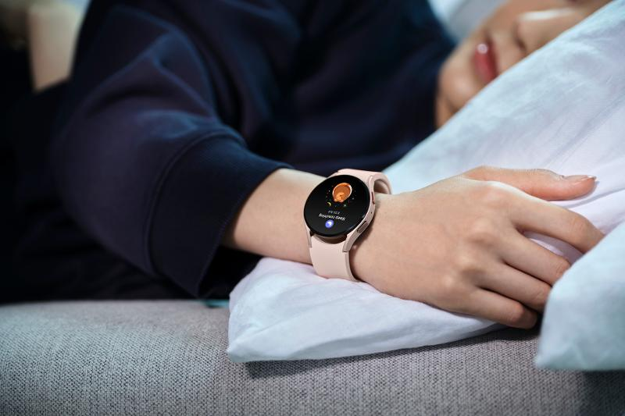

Filipinos are among the world's most sleep-deprived, according to a global health study. And, while a lack of sleep can be caused by a variety of factors such as work, illness, stress, excessive use of social media, and unhealthy eating habits, failing to get enough rest can lead to serious health problems in the long run.

Sufficient sleep demonstrates long-term benefits and allows body systems to work better. An adequate shut-eye has impacts on how people will function physically and mentally the next day. It also strengthens a person’s immunity from diseases and viruses.

Achieving a healthy sleeping routine is not easy, especially when people do not have the means to track their habits. With this in mind, Samsung launched its newest Galaxy Watch5 Series designed to enable users to achieve ideal sleeping patterns with the help of technology.

The smartwatch that knows you even with eyes closed

The Galaxy Watch5 and Watch Pro are both equipped with a Sleep Tracker that detects and analyzes users’ sleeping and snoring patterns as well as blood oxygen levels so they don’t forget the value of adequate rest.

These smartwatches also monitor all levels of sleep, including REM cycles, to assist users in adjusting their sleeping habits and informing them on how much rest is required to get through the day. They help plan users’ bedtime, detect their snoring, and track their sleep with four sleep stages: awake, light, deep, and REM using eight animal symbols that represent their sleep type. In addition, they even deliver advanced insights from the National Sleep Foundation to improve sleep quality and duration.

Aside from that, if users wish to quickly check their body composition the Samsung Galaxy Watch5 and Watch5 Pro have Bioelectrical Impedance Analysis (BIA) that provides precise measurements of their body fat percentage, skeletal muscle, and body water within 15 seconds. The smartwatches also sport BioActive Sensors, which can monitor blood pressure and test heart rhythms, making electrocardiogram (ECG) tests handy.

The Samsung Galaxy Watch5 and Watch5 Pro have revolutionized the way fitness enthusiasts and even beginners track their health. The features of both smartwatches provide accurate health data, inspiring users to sleep better and perform healthier routines. It also offers a battery capacity of 410mAh and 284mAh for the Galaxy Watch5, and 590mAh for the Galaxy Watch5 Pro, with fast-charging for longer usage and a maximized experience.

The importance of personalized feedback

Along with the enhanced features, Samsung knows that feedback is essential to improving progress. People believe that to be the best version of themselves, they need to know more and be guided properly. And Samsung doesn’t just listen, it engineers what's best for users. With that, the enhanced Galaxy Watch5 Series detects over 90 exercises and personal routines. It even provides personalized feedback based on the user's workout performance.

The ultra-stylish yet premium design of Samsung Galaxy Watch 5 Series is fit for any occasion and everyday function wear. Users may keep it on anywhere, anytime, rain or shine, as the smartwatch is water and sweat-resistant.

The Samsung Galaxy Watch5 Series is now available to be everyone’s fitness companion at the following prices and colors:

- Galaxy Watch5 (40mm) Bluetooth - PHP 16,990 (Available in Silver, Graphite, and Pink Gold)
- Galaxy Watch5 (40mm) LTE - PHP 19,990 (Available in Silver, Graphite, and Pink Gold)
- Galaxy Watch5 (44mm) Bluetooth - PHP 18,990 (Available in Graphite, Sapphire, and Silver)
- Galaxy Watch5 (44mm) LTE - PHP 21,990 (Available in Graphite, Sapphire, and Silver)
- Galaxy Watch5 Pro (45mm) Bluetooth- PHP 26,990 (Available in Black Titanium and Gray Titanium)
- Galaxy Watch5 Pro (45mm) LTE - PHP 29,990 (Available in Black Titanium and Gray Titanium)

From September 2 until September 30, customers will enjoy 50% off on the new Galaxy Buds2 Pro with every purchase of the Galaxy Watch5 or the Watch5 Pro. When purchased with the new Galaxy Z Fold4 or Z Flip4, they can enjoy 30% off on the Galaxy Watch5 Series, and 50% off on the new Galaxy Buds2 Pro.

Safe Samsung Shopping

Health and safety protocols are strictly followed in Samsung Experience Stores to keep consumers and employees safe. Adhering to the guidelines set by the Inter-Agency Task Force for the Management of Emerging Infectious Diseases, Samsung has implemented the mandatory use of face masks, and performs frequent sanitation in all stores.

Samsung Experience Stores also has unique QR health declaration codes to promote a safe and contactless contact tracing process. Product demonstrations are done side-by-side instead of face-to-face while keeping the required safe distance of one (1) meter to make sure everyone is socially distanced.

To find the nearest Samsung Experience Store, visit samsung.com/ph/samsung-experience-store/locations.

###

About Samsung Electronics Co., Ltd.
Samsung inspires the world and shapes the future with transformative ideas and technologies. The company is redefining the worlds of TVs, smartphones, wearable devices, tablets, digital appliances, network systems, and memory, system LSI and LED solutions. For the latest news, please visit the Samsung Newsroom at http://news.samsung.com.

IThese features are intended for general wellness and fitness purposes only. Not intended for use in detection, diagnosis, or treatment of any medical condition or disease. Availability of these features may vary by market or device. Requires Galaxy smartphone with Android 8.0 or later, 1.5GB RAM or more and the latest version of the Samsung Health app (version 6.22 or later).
Intended for general wellness and fitness purposes only. Not intended for use in detection, diagnosis, treatment, monitoring or management of any medical condition or disease. Any health-related information accessed through the device and/or application should not be treated as medical advice. Users should seek any medical advice from a physician. Do not measure your body composition if you have an implanted pacemaker or other implanted medical devices. Do not measure your body composition if you are pregnant. Measurement results may not be accurate if you are under 20 years old.
To measure, select your exercise before you start to workout.
Sleep features are intended for general wellness and fitness purposes only. Not intended for use in detection, diagnosis, treatment of any medical condition or sleep disorder. The measurements are for your personal reference only. Please consult a medical professional for advice
To record your snoring, wear your watch while you sleep and place your phone on a stable surface near your head, such as a nightstand, with the bottom of the phone pointed toward you.
Compared to Galaxy Watch4.

