NOW AVAILABLE: Seize the day with the latest Samsung wearable and hearable devices, with up to 50% off until September 30!

The recent Samsung Galaxy event unveiled the brand’s latest advancements in mobile experience, emphasizing their transformative role in making experiences greater than ever. As hands-free tech continues to prove its importance in users’ modern lifestyles, the brand showcased their newest line of wearable and hearable devices—the Galaxy Watch5 Series, and the Galaxy Buds2 Pro—all designed for seamless integration and flexible functionality in any situation.

Sleep and train better with the watches that know you best
The moment users start their day, the Galaxy Watch5 Series automatically allows users to reach the full potential of their energy and push fitness levels to new heights.

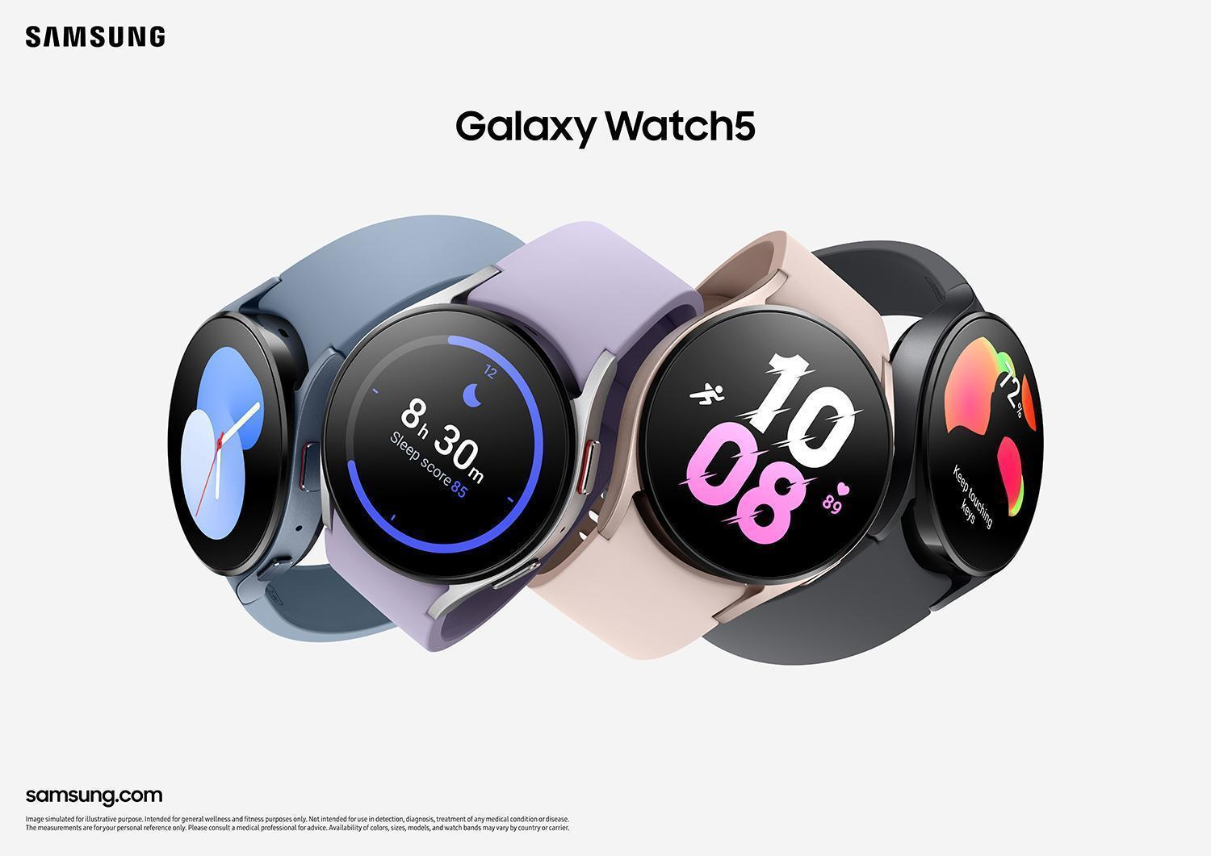

Morning workouts have never been so easy as the Galaxy Watch5 counts steps, calories, and even detects personal routines. There are over 90 exercises that users can track and the smartwatch not only provides health data, but also shares personalized feedback that helps improve its users’ overall health.

Coupled with the Galaxy Buds2 Pro, workouts can feel more energetic with its Intelligent 360 Audio feature, which creates an immersive audio experience and delivers superior sound quality to complement their routine.

Meanwhile, the Galaxy Watch5 Pro is perfect for athletes and outdoor fitness enthusiasts through its Route Workout feature that enables users to import their pre-set route files so they can travel easily along the route. It also has a Track Back feature, which allows cyclists and hikers to seamlessly return to where they started their exercise routes.

In addition, the Galaxy wearables provide a holistic health experience with its new Stress Management tracker, which immediately detects high levels of stress and offers breathing exercises to help keep users centered and focused.

The Galaxy Watch5 Series sports Samsung’s most groundbreaking BioActive Sensor to date that combines three powerful health sensors – Optical Heart Rate, Electrical Heart Signal and Bioelectrical Impedance Analysis. With this, it delivers extensive readings that include heart rate, blood oxygen level, and even stress levels.

Phone and video call audio will also be much crisper with the Intelligent Active Noise Control of the Galaxy Buds2 Pro giving a noise-free call through its 3-high Signal-to-Noise Ratio microphones that eliminate unwanted outside sounds. Samsung also made switching to in-person conversations easier with Voice Detect, so users can talk to their friends without the need to take their earbuds off.

At night, when users are already asleep, the Galaxy Watch5 Series remains a fitness companion, with its improved Sleep Tracking technology, which identifies sleeping patterns and keeps an eye on sleep time to advise healthy sleeping habits.

Face the day confidently with these new Samsung wearables. Both devices feature a sleek yet durable design for everyday functional wear. These are also water and sweat-resistant so users can use them rain or shine. Without a doubt, the Samsung Galaxy Watch5 Series and the Galaxy Buds2 Pro are packed with innovative hardware and software to meet users' everyday needs.

The Galaxy Watch5, Galaxy Watch5 Pro, and Galaxy Buds2 Pro are now available via samsung.com, Samsung Experience Stores, Authorized Samsung Stores, Lazada, Shopee, Abenson.com, and MemoXpress Online.

Tha Galaxy Watch5 Series is available for the following prices and colors:
- Galaxy Watch5 (40mm) Bluetooth - PHP 16,990 (Available in Silver, Graphite, and Pink Gold)
- Galaxy Watch5 (40mm) LTE - PHP 19,990 (Available in Silver, Graphite, and Pink Gold)
- Galaxy Watch5 (44mm) Bluetooth - PHP 18,990 (Available in Graphite, Sapphire, and Silver)
- Galaxy Watch5 (44mm) LTE - PHP 21,990 (Available in Graphite, Sapphire, and Silver)
- Galaxy Watch5 Pro (45mm) Bluetooth- PHP 26,990 (Available in Black Titanium and Gray Titanium)
- Galaxy Watch5 Pro (45mm) LTE - PHP 29,990 (Available in Black Titanium and Gray Titanium)

Meanwhile, the Galaxy Buds2 Pro is available for PHP 6,495 in three trendy colors: Bora Purple, Graphite, and White.

From September 2 until September 30, customers will enjoy 50% off on the new Galaxy Buds2 Pro with every purchase of the Galaxy Watch5 or the Watch5 Pro. When purchased with the new Galaxy Z Fold4 or Z Flip4, they can enjoy 30% off on the Galaxy Watch5 Series, and 50% off on the new Galaxy Buds2 Pro.

To know more about the new Galaxy Watch5 Series and Galaxy Buds2 Pro, visit samsung.com/ph.

Safe Samsung Shopping

Health and safety protocols are strictly followed in Samsung Experience Stores to keep consumers and employees safe. Adhering to the guidelines set by the Inter-Agency Task Force for the Management of Emerging Infectious Diseases, Samsung has implemented the mandatory use of face masks, and performs frequent sanitation in all stores.

Samsung Experience Stores also has unique QR health declaration codes to promote a safe and contactless contact tracing process. Product demonstrations are done side-by-side instead of face-to-face while keeping the required safe distance of one (1) meter to make sure everyone is socially distanced.

To find the nearest Samsung Experience Store, visit samsung.com/ph/samsung-experience-store/locations.

###

About Samsung Electronics Co., Ltd.
Samsung inspires the world and shapes the future with transformative ideas and technologies. The company is redefining the worlds of TVs, smartphones, wearable devices, tablets, digital appliances, network systems, and memory, system LSI and LED solutions. For the latest news, please visit the Samsung Newsroom at http://news.samsung.com.

