3 ways to stay healthy with the Samsung Galaxy Watch5 Series
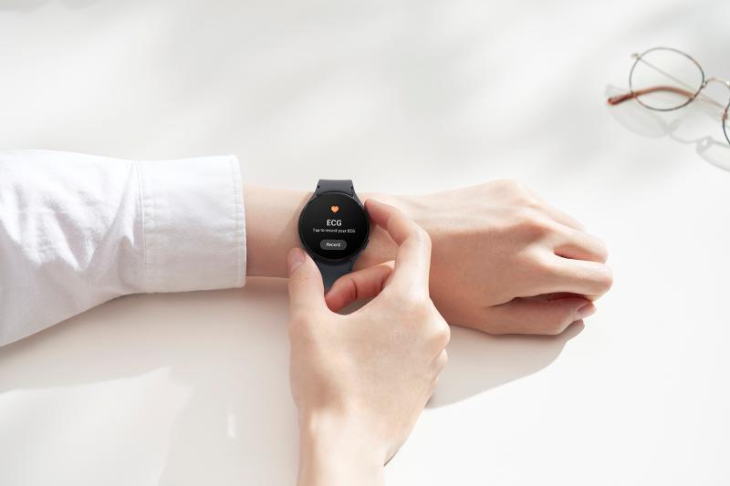

For sure each of us has come across the phrase “health is wealth” more than once in our lives. And while this may sound cliché, the message remains loud and clear especially in this day and age. It is a fact that building a healthy lifestyle comes with many long-term benefits, physiologically, mentally, and emotionally. And if the pandemic taught the world anything, it’s that prioritizing our health is something that needs to be done now.
Quitting unhealthy habits and starting healthy ones can be a lot of work. But with a reliable smart device that is intuitive and stylish, maintaining an active lifestyle can be a little less daunting. These days, it pays off to have a personalized everyday wellness companion. And this is exactly why fitness seekers and wellness enthusiasts will love Samsung’s smartest and most durable watches to date: the Galaxy Watch5 Series.
With the Galaxy Watch5 and Watch5 Pro’s updated and upgraded features, it’s easy and fun to start living healthy. Here are some ways the Samsung Galaxy Watch5 Series makes it easy to stay healthy daily:

- Define health goals with its Advance BioActive Sensor
The Galaxy Watch5 Series is equipped with Samsung’s unique BioActive Sensor that monitors holistic health metrics such as body fat percentage, muscle mass, heart rate and rhythm, and blood oxygen levels. Based on the data it collects, the smartwatch acts like a personal trainer as it gives personalized tips and insights to help develop healthier habits.
Users set themselves up for success by identifying overall health goals and milestones with the smartwatch’s three powerful health sensors: Bioelectrical Impedance Analysis Sensor (BIA), Electric Heart Signal, and Optical Heart Rate Sensor.
- Exercise regularly and track progress
There are many things that can stop a person from working out, especially in the beginning. Exhaustion and laziness can make it absolutely difficult to commit to a fitness routine and fight the urge to just lie down and rest.
With the Galaxy Watch5 Series’ Fitness Tracker, there’s always a form of exercise that fits different types of schedules and lifestyles. It can track over 90 workouts, including walking, running, elliptical, rowing, swimming, and dynamic high-movement activities. When you have a smartwatch that shows and monitors your steps, calorie intake, and routine completion, it’s easy to commit to being active, one goal at a time.
- Understand sleeping patterns and reset the body’s circadian rhythm
A properly-aligned circadian rhythm affects the body’s physical performance and cardiovascular activity. Having a healthy sleep-wake schedule allows people to function at their best, which consequently promotes positive mental well-being.
Luckily, the Galaxy Watch5 Series is now powered by an upgraded Sleep Tracking feature. It becomes a 24-hour health guard, helping people plan their bedtime, detect snoring, and track sleep stages. It also has eight animal sleep symbols that represent different sleep types. This helps people better understand patterns and make necessary behavioral changes.
Defining health milestones and achieving them is more satisfying with a smartwatch that literally knows every step taken towards wellness. That it carries a sophisticated design and is built with essential functional features is just a bonus.
All models of the Galaxy Watch5 Series boast a double titanium casing, a powerful Exynos W920 processor, and come with 16GB of storage. It also carries a long-lasting and fast-charging battery of up to 590mAh. Other features include compatibility with any 8.0 Android phone or higher, Wi-Fi support, and Bluetooth 5.2.
The Samsung Galaxy Watch5 Series is now available to be everyone’s fitness companion at the following prices and colors:

- Galaxy Watch5 (40mm) Bluetooth - PHP 16,990 (Available in Silver, Graphite, and Pink Gold)
- Galaxy Watch5 (44mm) Bluetooth - PHP 18,990 (Available in Graphite, Sapphire, and Silver)
- Galaxy Watch5 Pro (45mm) Bluetooth- PHP 26,990 (Available in Black Titanium and Gray Titanium)

What’s more, with every purchase of the Galaxy Watch5 or the Galaxy Watch5 Pro. Customers are entitled to 50% off on the latest Galaxy Buds2 Pro until October 31. Samsung is also offering discounts of up to 30% off on the Galaxy Watch5 Series when purchased with participating Samsung Galaxy products including the latest Galaxy Z Fold4 or Galaxy Z Flip4 as part of its cross-sell promotions.

To know more about the Watches That Know You Best, visit samsung.com/ph.

Safe Samsung Shopping

Health and safety protocols are strictly followed in Samsung Experience Stores to keep consumers and employees safe. Adhering to the guidelines set by the Inter-Agency Task Force for the Management of Emerging Infectious Diseases, Samsung has implemented the mandatory use of face masks, and performs frequent sanitation in all stores.

Samsung Experience Stores also has unique QR health declaration codes to promote a safe and contactless contact tracing process. Product demonstrations are done side-by-side instead of face-to-face while keeping the required safe distance of one (1) meter to make sure everyone is socially distanced.

To find the nearest Samsung Experience Store, visit samsung.com/ph/samsung-experience-store/locations.

###

About Samsung Electronics Co., Ltd.
Samsung inspires the world and shapes the future with transformative ideas and technologies. The company is redefining the worlds of TVs, smartphones, wearable devices, tablets, digital appliances, network systems, and memory, system LSI and LED solutions. For the latest news, please visit the Samsung Newsroom at http://news.samsung.com.

